(BANKING APPLICATION TESTING AUTOMATION)

SEWI ZC425T PROJECT WORK

By

AARFEEN AALIA

201519TW693

Project Work Work carried out at

Wipro Technologies, Pune

BIRLA INSTITUTE OF TECHNOLOGY AND SCIENCE

Pilani (Rajasthan) India

May, 2019

SEWI ZC425T PROJECT WORK

(BANKING APPLICATION TESTING AUTOMATION)

Submitted in partial fulfilment of the requirements of

B. Tech Information Systems Degree Program

By

AARFEEN AALIA

201519TW693

Under the supervision of

(Ms. Snehal Balasaheb Margle )

Project Work carried out at

Wipro Technologies, Pune

BIRLA INSTITUTE OF TECHNOLOGY AND SCIENCE

PILANI (RAJASTHAN)

(May, 2019)

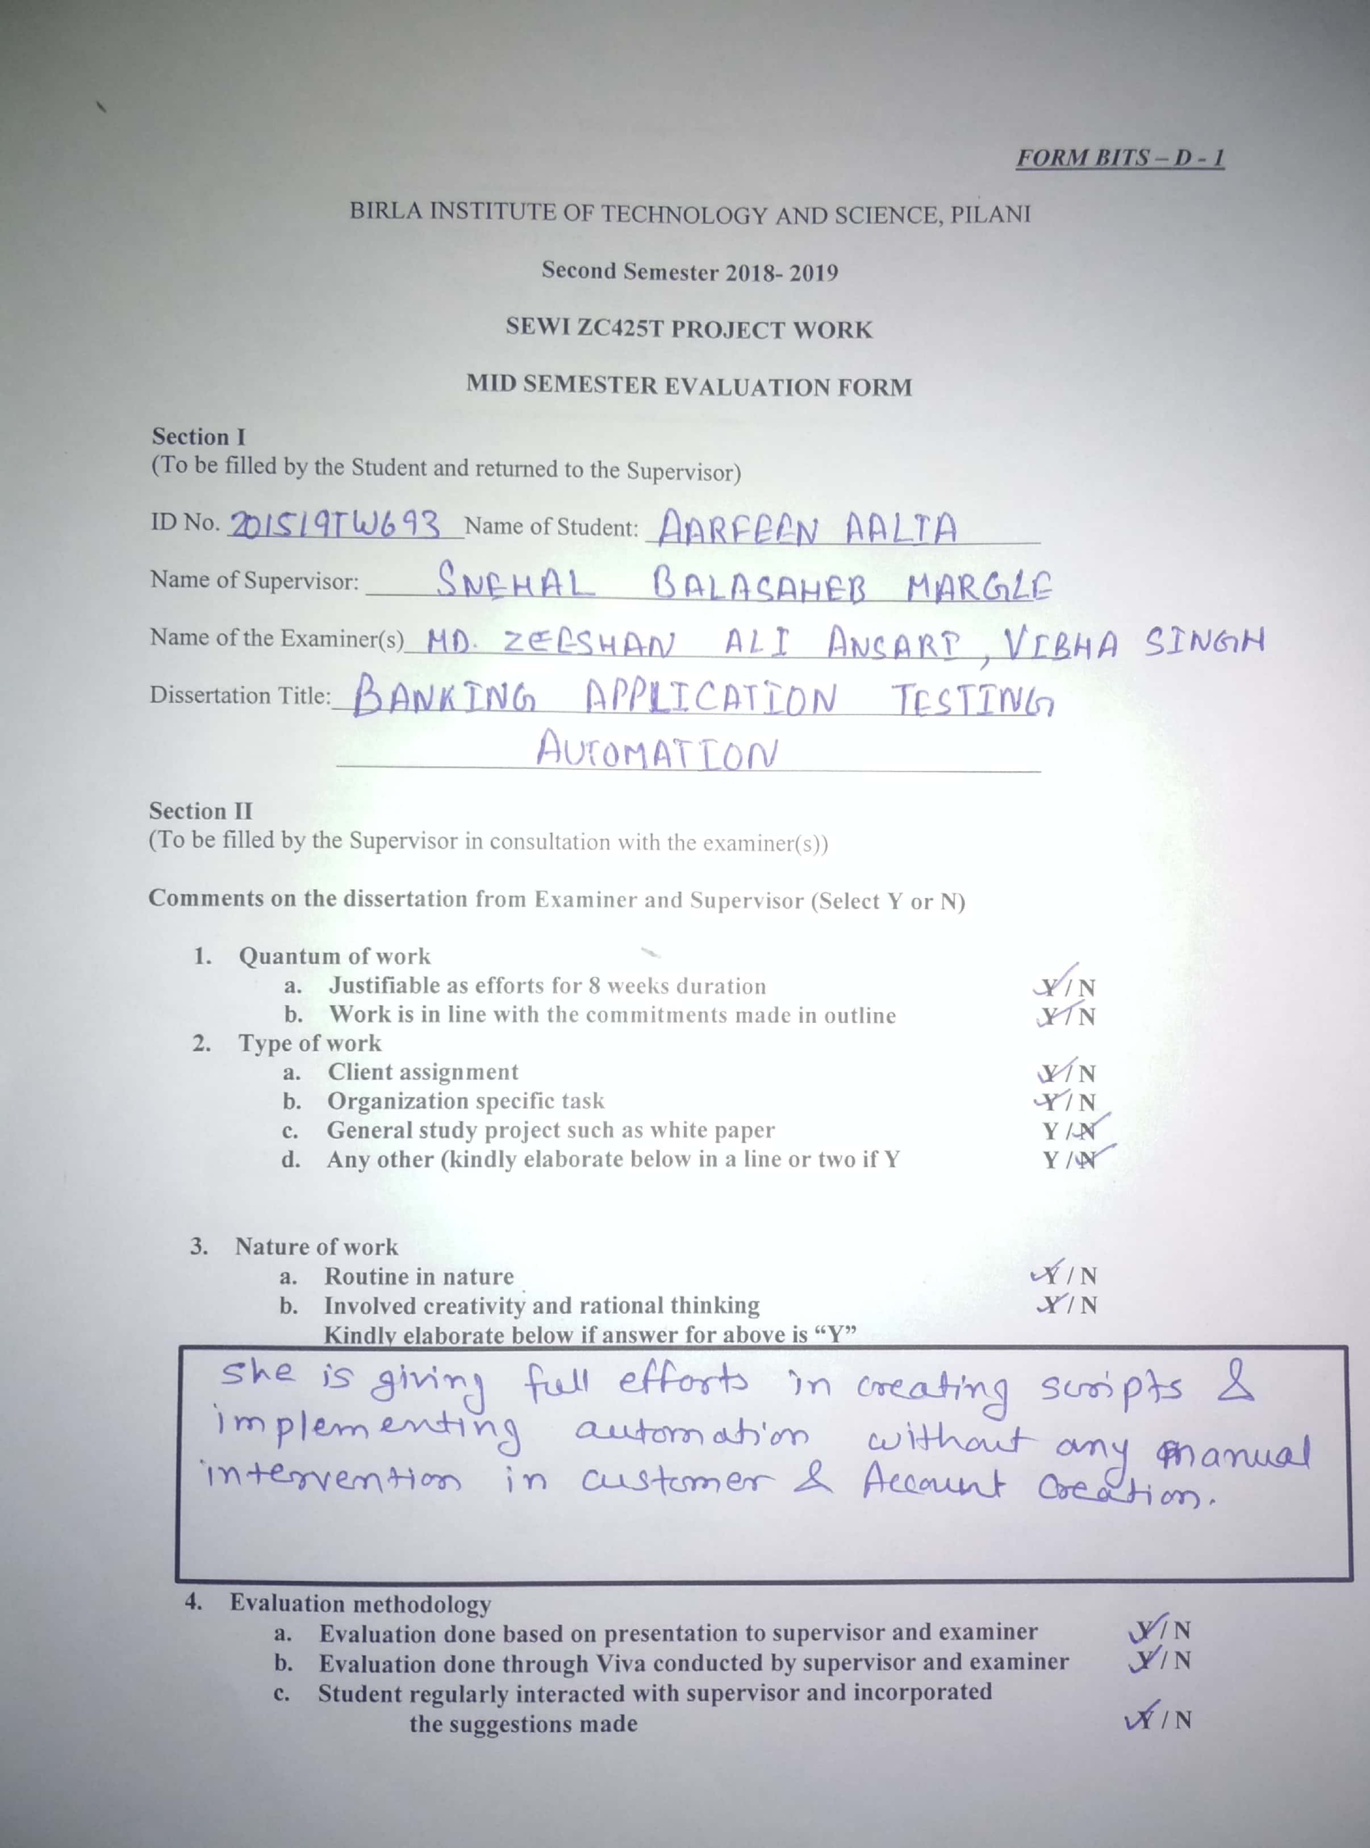

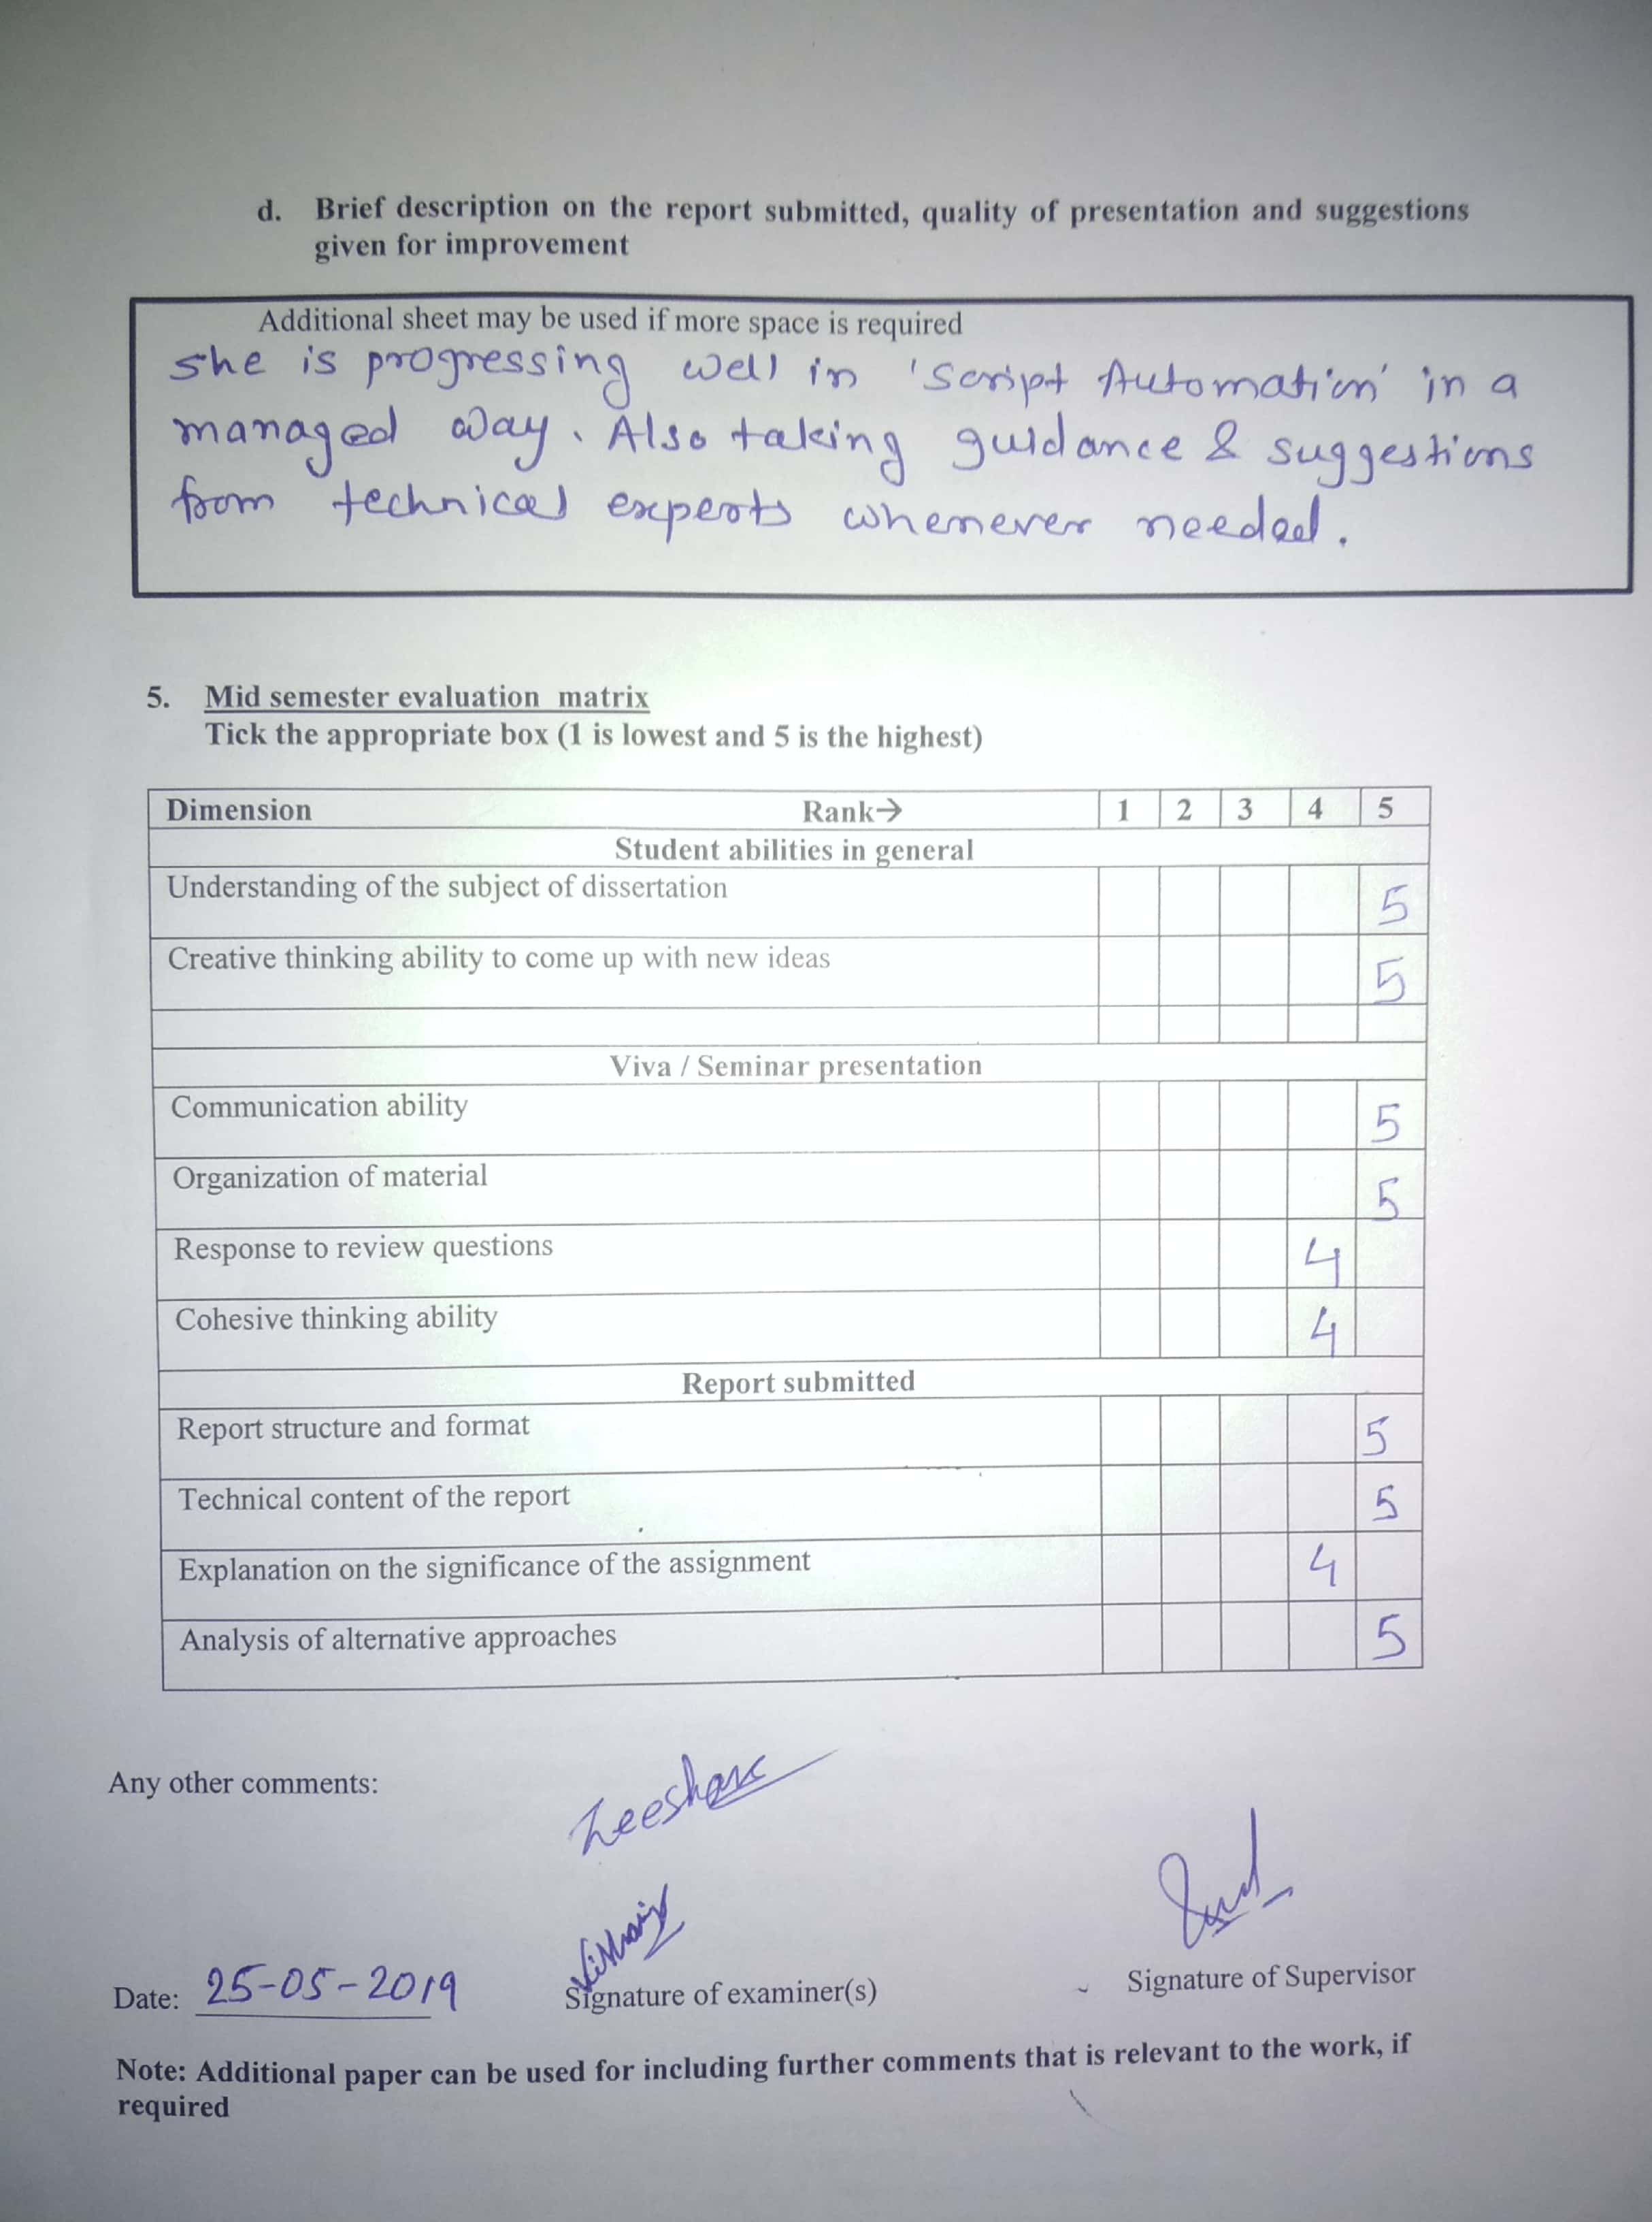

# Progress of the Report

**Current Project works carried out:**

**Requirement Gathering:**

I have gathered required information regarding the Bank Web Application used by the employees in a Bank, required space and knowledge of Selenium, cucumber and BDD Framework to automate the Application functionalities using scripts.

**Planning:**

* Identified the functionalities of Application which can be automated that were done manually by the employees of the bank.
* Creating a dummy Bank Website using Java, Servlet, JSP and Database similar to Application used by the Bank.
* Also working on the Test script which will automate the Customer and account creation process in Bank using BDD Framework

**Remaining Project Implementation:**

**Code builds:**

* Need to complete the Test script for Customer and account creation process and some other feature of the Application.
* Need to build the test case and test scenarios to test Application.

**Implementation**

▪ Create Test Data to test the scenarios and run the script

## TABLE OF CONTENTS

1. Introduction
   1. Objective
   2. Scope

1. Literature Review
   1. Terms used In Automation

3. Installation Pre-Requisites

3.1 Selenium Installation

3.2 Cucumber Installation

4. Bank Dummy Website

4.1 JSP page

4.2 Servlet

4.3 GUI Page

5. Test Strategy

* 1. Test Scenario
  2. Test Script

**1. INTRODUCTION**

Banking software is [enterprise software](https://en.wikipedia.org/wiki/Enterprise_software) that is used by the [banking industry](https://en.wikipedia.org/wiki/Banking_industry) to provide and manage the [financial products](https://en.wikipedia.org/wiki/Financial_product) they provide. Within [retail banks](https://en.wikipedia.org/wiki/Retail_bank), banking software typically refers to [core banking](https://en.wikipedia.org/wiki/Core_banking) software and all its interfaces that allows them to connect to other modular software and to the [interbank networks](https://en.wikipedia.org/wiki/Interbank_network).

Employees working in Bank use web application to open new accounts, maintain account and customer details and add customers to existing accounts .Also used to transfer funds within the bank accounts and even to other banks etc.

Different types of account can be created in a bank such as Individual, Joint, Trust account or corporate account. Each detail is stored in databases such a way that it can be easily retrieved whenever needed by the bank.

Testing such a vast Bank Application with different functionalities manually is really time consuming. Automating some of the process can reduce the effort and time consumed testing the features manually.

### Objective

The BFSI (Banking, Financial services and Insurance) sector is the biggest consumer of IT services. Banking Applications directly deal with confidential financial data.

It is mandatory that all the activities performed by banking software run smoothly and without any error. Banking software performs various functions like transferring and depositing fund, balance inquiry, transaction history, withdrawal and so on.

Testing banking application assures that these activities are not only executed well but also remain protected from hackers. For banking application Selenium can be used which is the leading tool that is used for automating the web application and mobile applications in all the leading MNC’s. One of the main reasons why Selenium Testing Framework is used is because it is the Open Source Software.

Mostly Selenium is used for functional testing. Selenium is integrated with Cucumber which makes it easy to read and to understand the application flow.

Cucumber tool is based on the Behavior Driven Development framework that acts as the bridge between following people such as Software Engineer and Business Analyst, Manual Tester and Automation Tester and Manual Tester and Developers.

Cucumber also benefits the client to understand the application code as it uses Gherkin language which is in Plain Text. Anyone in the organization can understand the behavior of the software. The syntax's of Gherkin is in simple text which is readable and understandable.

### 1.2 Scope

* The primary objective of this project is to minimize the physical efforts and improve the tester productivity.
* This project will generate test report in a well-documented format which can be referred in future as well.
* This project will reduce the manual error done while testing the sensitive applications.
* This project will also help to track the bugs and defects found most often.
* This project is a step towards saving time on testing application.

# 2. Literature review

**2.1 Terms used In Testing Automation**

**Automaton Testing**

It is a Software testing technique to test and compare the actual outcome with the expected outcome. This can be achieved by writing test scripts or using any automation testing tool.

**Acceptance criteria**

The exit criteria that a component or system must satisfy in order to be accepted by a user, customer, or other authorized entity.

**Test Cases**

It is a set of conditions or variables under which a tester will determine whether a system under test satisfies requirements or works correctly.

**Test script**

Itis a set of instructions (written using a scripting/programming language) that is performed on a system under test to verify that the system performs as expected.

**Test Scenarios**

It is defined as any functionality that can be tested. It is a collective set of test cases which helps the testing team to determine the positive and negative characteristics of the project.

**Test Data**

Test data is the data that is used in tests of a software system.

**Regression Testing**

It is defined as a type of software testing to confirm that a recent program or code change has not adversely affected existing features.

3. Installed Pre-Requisites

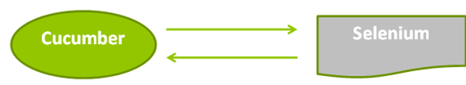

**Steps to install Selenium, cucumber**

1. Before we start integration cucumber with selenium we need the following items:-

Selenium jar files: Selenium-server-standalone

Downloaded at <http://www.seleniumhq.org/download/>

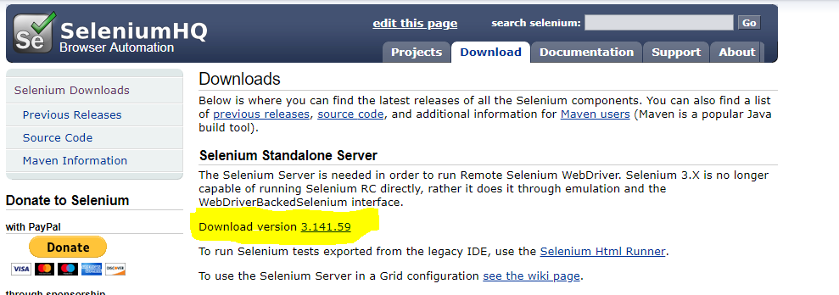

1. Jar files For Cucumber :

* Cucumber-core
* Cucumber-html
* Cucumber-java
* Cucumber-junit
* Cucumber-jvm-deps
* Cucumber-reporting
* Hemcrest-core
* Gherkin
* Junit

searched files and downloaded them one by one individually.

For example downloaded one of the jar files, i.e., "Cucumber-core."

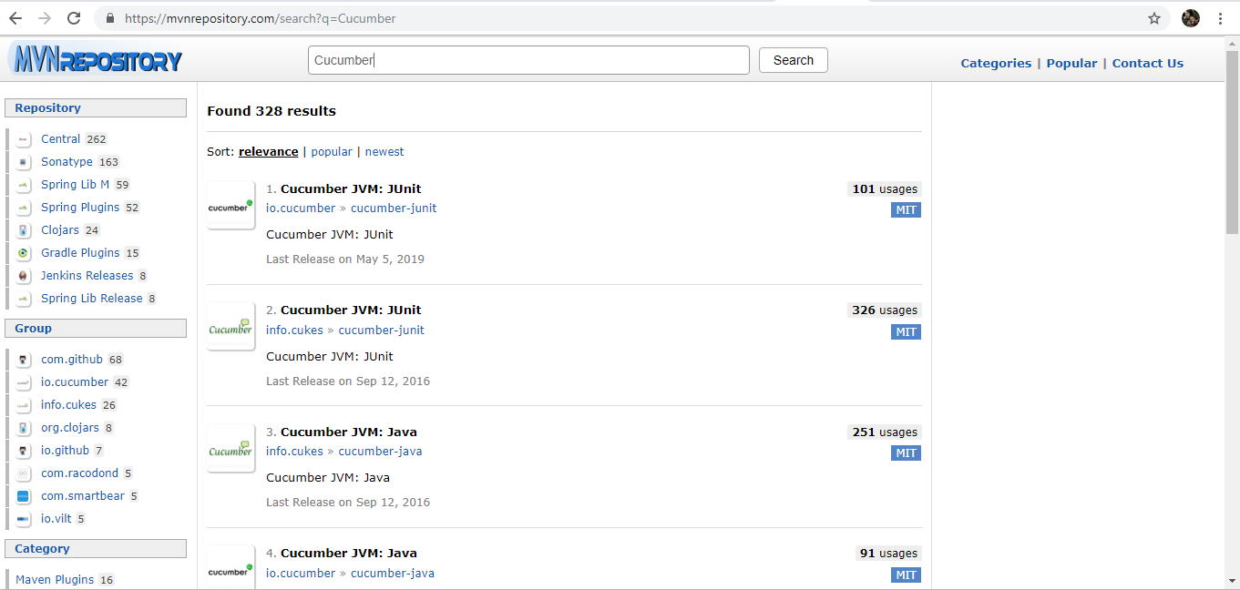

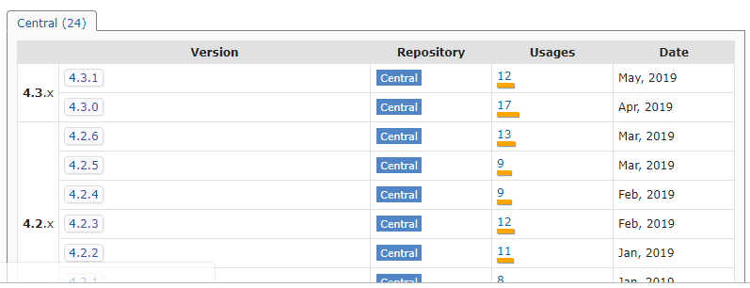

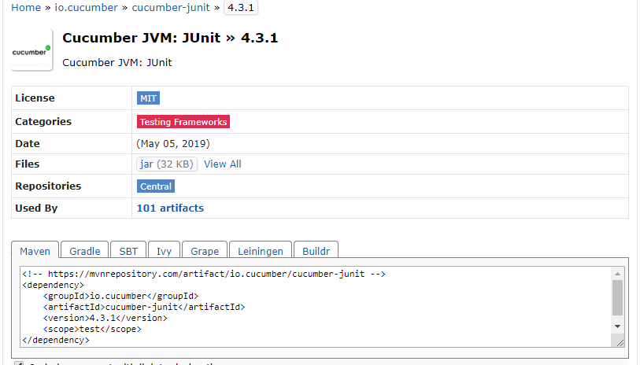

4. Bank Dummy Application

Creating similar dynamic website using Servlet and JSP for automation testing similar to bank Application.

Bank will be able to login to Web Application using their User ID and Password. Credentials are stored in Database. It will be used in the bank for opening account for customers, search for the customer using Customer id or Account number who already have accounts in bank.

Through this application bank will able to store, maintain and change Customer and account details

My SQL Database is used to store Customer and account details with account number and Customer ID.

Some of the JSP and servlet codes and their output are pasted below.

**4.1 JSP pages**

1. Login Page

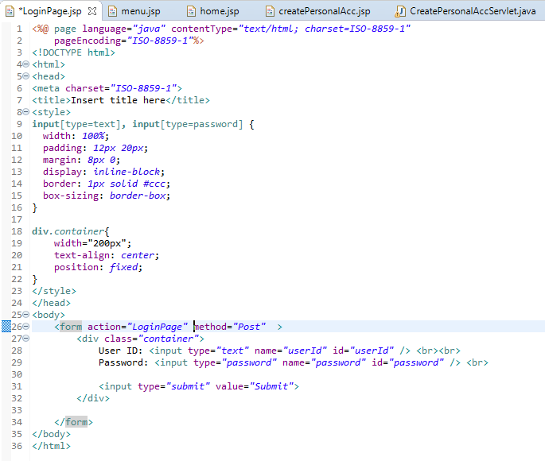

**2.Menu Page**

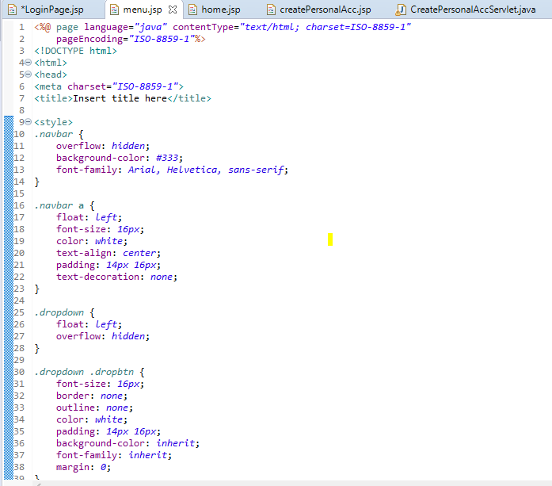

1. **Create Personal Account**

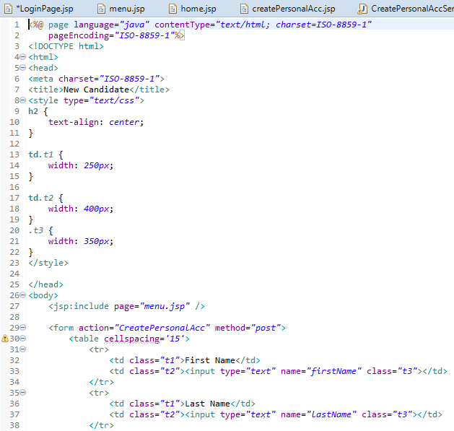

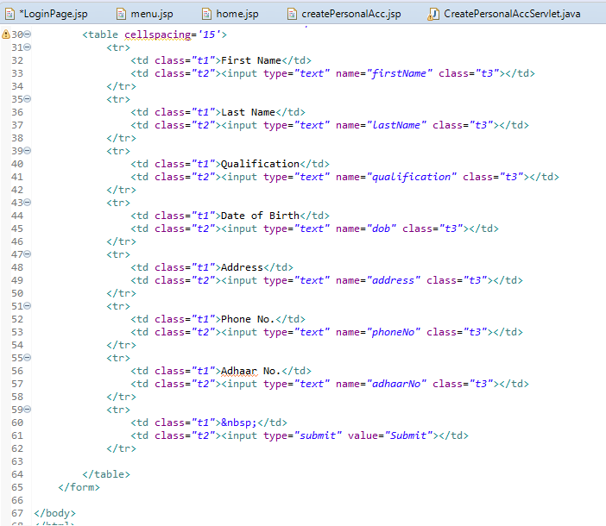

**4.2 Servlet**

1. Login Page Servlet

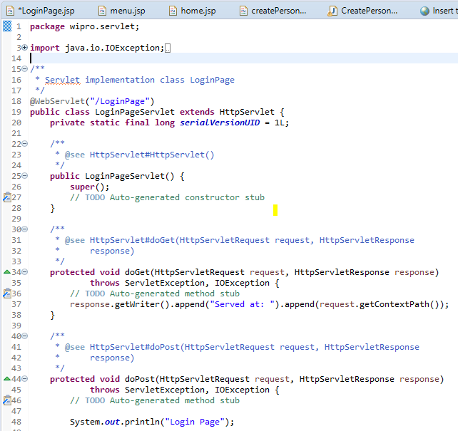

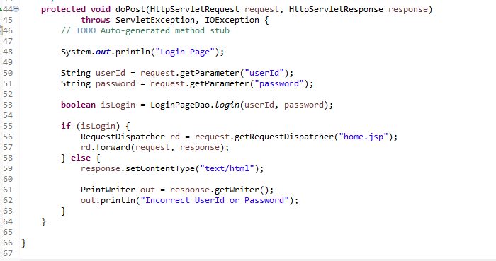

1. **Create Personal account Servlet**

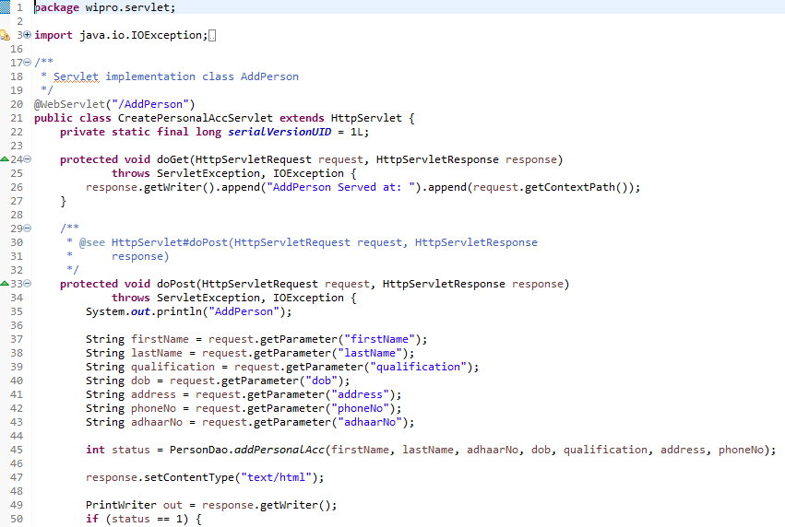

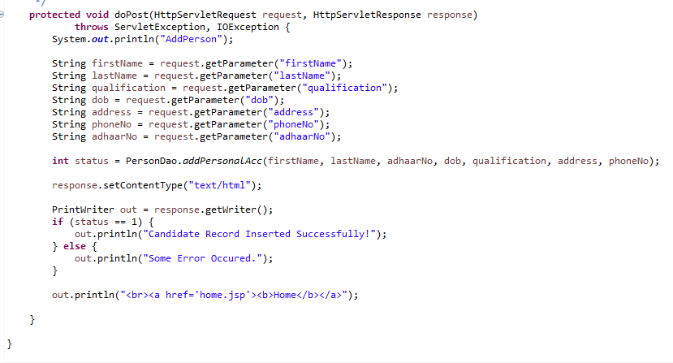

**4.3 GUI**

1. Login Page for bank employees to login.

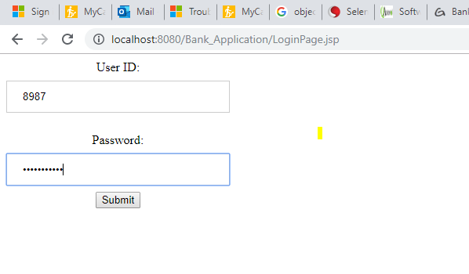

2 . Menu page to search and select type of account to be created.

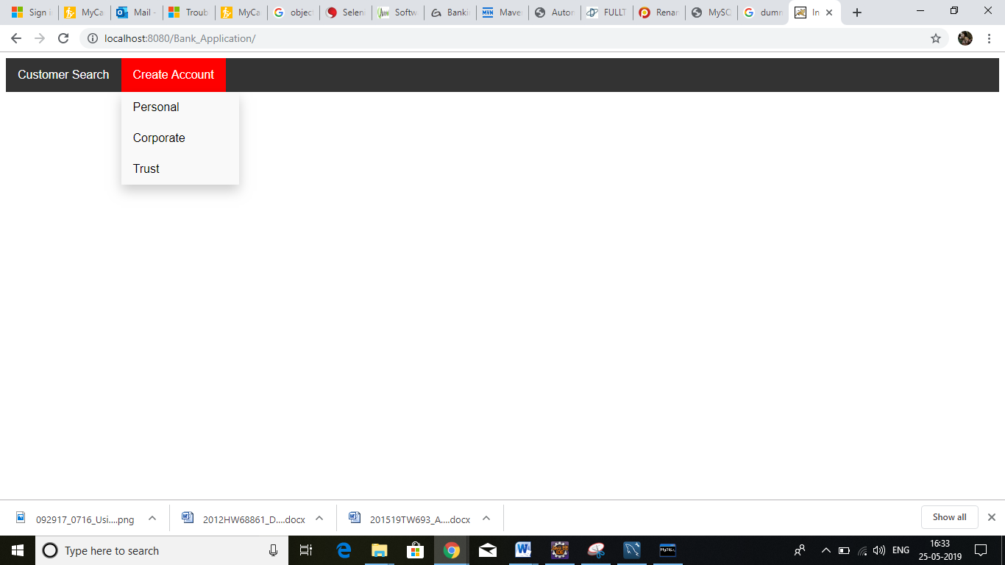

1. Page to fill Customer details.

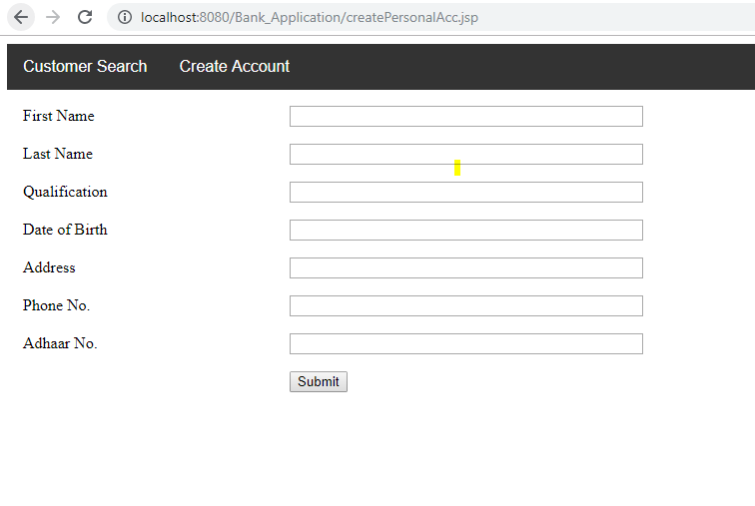

5.Test Strategy

5.1 Test Scenario

1. User launches the web Application

2. Login to the Application to open account for a customer.

3. Clicks on create customer.

4. Chooses the type of account to be created.

5. Enters the Customer details in the Detail page as per the account type.

6. Clicks on submit button.

7. Clicks on Home button.

8. Clicks on account search link.

9. Enters the account number to be searched to retrieve the details of the account and the customer

To be continued…………..

5.2 Test Script

Automating the Account and customer creation process using selenium, TestNG and Cucumber. Framework used is BDD Framework with Gherkin language.

To be continued…………..